Enabling web traffic insight for your static website in Azure
Pre-requisites:
- Static web app
- Javascript code
- Log analytics workspace
- Application Insights
After deploying your static website, you can create a log analytics workspace account
First search for Log Analytics workspaces and click create
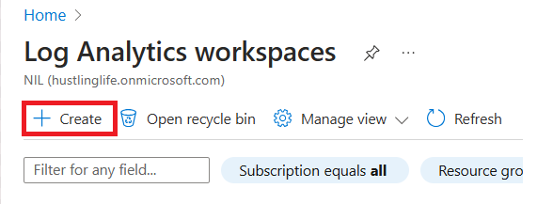
Follow steps as per screenshot below

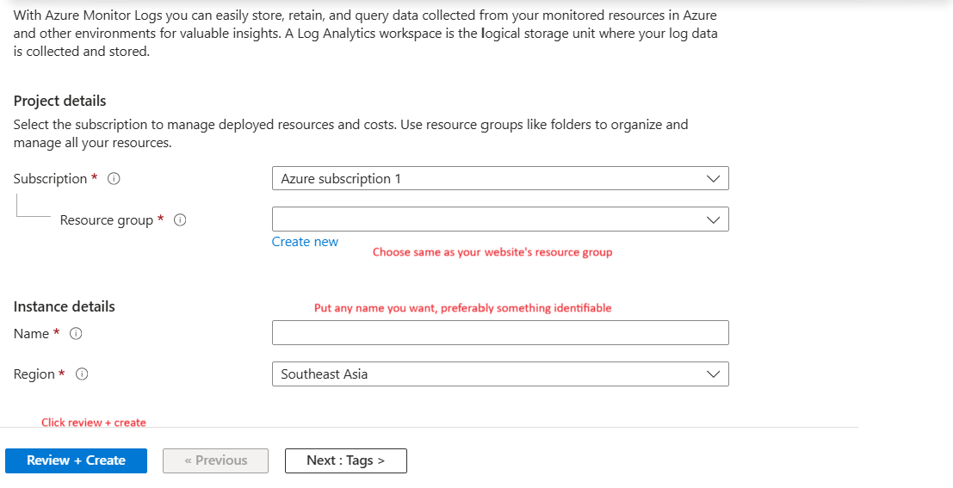
Search for application insights and then click on Create
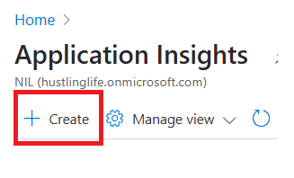

Follow the steps as the screenshot below
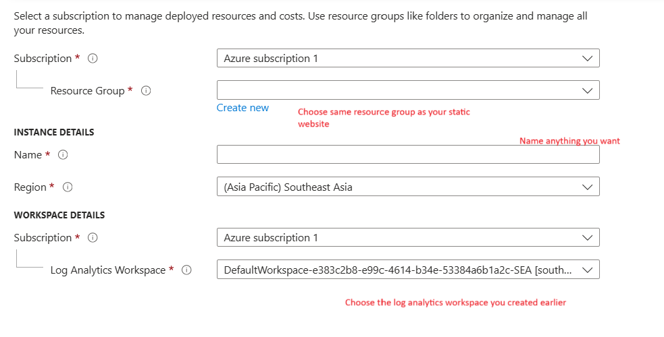
Now go to the application insight resource you created > at the overview page, on the right side should have the instrumentation key stated (everything after Key=). Copy it down
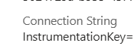

Head to this website (https://learn.microsoft.com/en-us/azure/azure-monitor/app/javascript-sdk?tabs=javascriptwebsdkloaderscript#snippet-based-setup) and copy the script shown as below and paste inside the head section of your html page
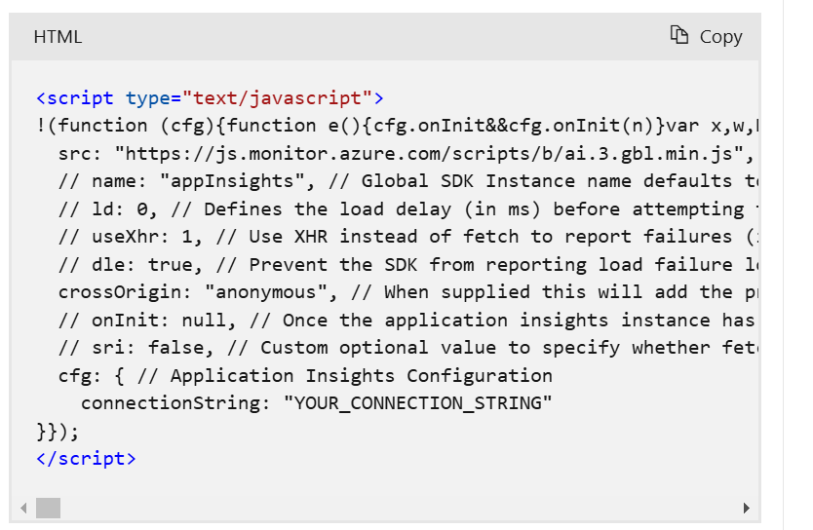

Next, replace the connectionstring part with
connectionString: "InstrumentationKey=putyourinstrumentationkeyhere”
Done! You can now deploy your website. How do you view the page visits? Go back to your application insight resource and head to Investigate > Performance
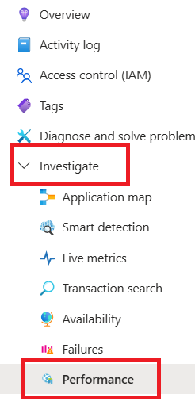
Switch this toggle to browser, you can view page view counts below
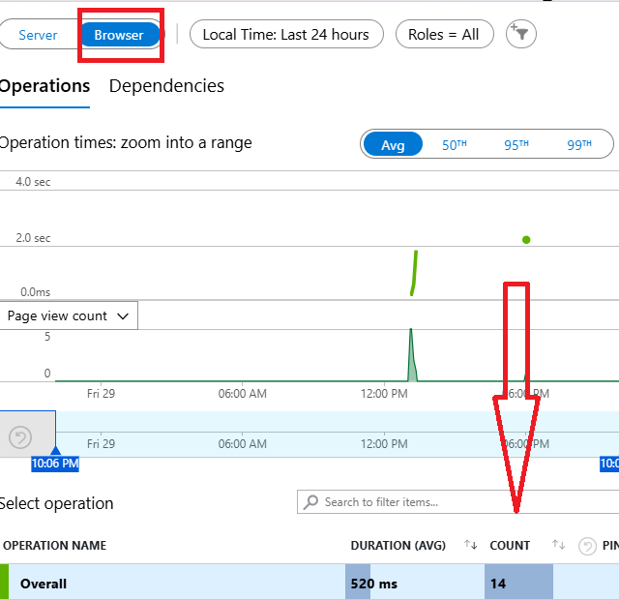
You can also play around with the filters, which lets you view even page views filtered by countries
